Requirements/Design Specification

**April 2015 Bug Fixes**

**CR 13635**

Revision History

|  |  |  |  |
| --- | --- | --- | --- |
| **Date** | **Revision** | **Description** | **Author** |
| 3/12/2015 | 1.0 | Initial Version with Requirements | Roger Behm |
|  |  |  |  |
|  |  |  |  |
|  |  |  |  |
|  |  |  |  |

The information furnished herein by Republic Services Inc. is proprietary and confidential to Republic Services Inc. personnel and is not to be duplicated, published, or disclosed to any third party in whole or in part without permission from Republic Services, Inc.

© Copyright 2012, Republic Services Inc. - All rights reserved.

Table of contents

1 Business Requirements 6

1.1 Purpose of the Design Specification 6

1.1.1 Bug list for current release 6

2 Assumptions 6

3 Design 7

3.1 #483 For a Large Container Quote, the Help Text on the Total Estimated Hauls/Month is Wrong 7

3.2 #474 Rental pricing for multiple large containers showing per month per container. 7

3.3 #473 Additional Comp Changes 7

3.4 #468 Division 4960 (S. Alabama) CSA has Florida T&C's 8

3.5 #466 Customer CSA Printing on 3 Pages 8

3.6 #446 InfoPro is receiving duplicate XML records 8

3.7 #337 Capture not picking up correct Rate for EXT (Extra Lift) 9

3.8 #265 VCD for removal fee on customer owned container decrease service 11

3.9 #233 Approval sent when waiving fees on Existing Cust that have flags already turned off 11

3.10 #59 Change of Owner: backdating, start date and bill to information 11

4 InfoPro Interface 12

5 Report Changes 12

6 Appendix 12

# Business Requirements

## Purpose of the Design Specification

This document highlights items to be fixed and implemented for the titled release. Most of these issues are bug fixes to be fixed by code logic. No new attributes are planned and existing attributes should not be repurposed.

### Bug list for current release

Items crossed out indicated work that failed testing and is being pushed to a different release.

| GitHub Item  Number | **Description** |
| --- | --- |
| ~~458~~ | ~~Existing Customer New Container VCD not on CSA if CSA box is not checked~~ |
| ~~420~~ | ~~Disposal Site Missing - Correct in CMC, Showing in Test, Missing in Prod~~ |
| ~~407~~ | ~~Admin fee on Customer Facing CSA waived for existing customer with Admin fee yes~~ |
| 483 | For a Large Container Quote, the Help Text on the Total Estimated Hauls/Month is Wrong |
| 474 | Rental pricing for multiple large containers showing per month per container |
| 473 | Additional Comp Changes |
| 468 | Division 4960 (S. Alabama) CSA has Florida T&C's |
| 466 | Customer CSA printing on 3 pages |
| 446 | InfoPro is receiving duplicate XML records |
| 337 | Capture not picking up correct Rate for EXT (Extra Lift) |
| ~~291~~ | ~~Divisions that don't charge Admin fees bug~~ |
| 265 | VCD for removal fee on customer owned container decrease service |
| 233 | Approval sent when waiving fees on Existing Cust that have flags already turned off |
| 59 | Change of Owner: backdating, start date and bill to information |

# Assumptions

NA

# Design

## #483 For a Large Container Quote, the Help Text on the Total Estimated Hauls/Month is Wrong

**Issue**

For a Large Container Quote, the Help Text on the Total Estimated Hauls/Month is Wrong. It currently instructs the user that they should calculate out the rate when they shouldn't.

**Design**

We recommend it read: This field is the estimated hauls/month per container. Ex: If you have 2 - 40 yard Open Tops that are to be hauled 3x/month each, the Total Estimated Hauls per Container per Month equals 3. It is used to calculate hauling costs. The Proposal and Sample Invoice will use this field to calculate monthly haul charges.

**BI or InfoPro**

No Impact

## #474 Rental pricing for multiple large containers showing per month per container.

**Issue**

Rental for large container is showing monthly amount in line item and monthly totals and not taking frequency into account if more than one container.

**Design**

Multiplied the market rental rate with quantity to generate market rental rate per month for calculations.

**BI or InfoPro**

No Impact

## #473 Additional Comp Changes

**Issue**

We should not provide term compensation on MTM or 12 month Terms. Only credit for 24 or 36 month terms.

**Design**

The payment for a non-rate restricted account will only be eligible for contract terms of 24 months or greater. Contract terms of MTM or 12 months will not qualify for the rate restriction additional payment.

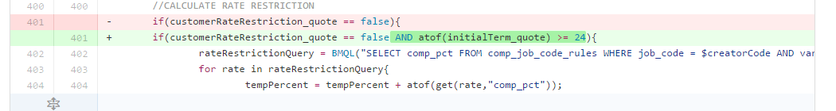

**BI or InfoPro**

No Impact

## #468 Division 4960 (S. Alabama) CSA has Florida T&C's

**Issue**

Division 4960 is in S. Alabama, but the CSA is Florida and has Florida T&C.

**Design**

Discussed with DSM. They need the CSAs for 4960 to mirror the same CSA options as 4986. Division 4986 has only the standard options. There will no longer be a CSA dropdown for this division, only Standard Permanent and Temporary CSAs will be included.

**BI or InfoPro**

No Impact

## #466 Customer CSA Printing on 3 Pages

**Issue**

Divisions 3421, 4853, 4852, 4855, 4862 on Customer Facing CSA have double spaces between paragraphs on page 2 that is pushing to another page.

**Design**

Remove double spacing.

**BI or InfoPro**

No Impact

## #446 InfoPro is receiving duplicate XML records

**Issue**

In the last couple of months (I think really since December) we have been receiving a lot of quotes more than once. Our logic marks them as duplicates so we catch them and they error out before processing. However, the developers get paged and have to investigate the error so it is taking up a bit of their time.

**Design**

From Oracle:

"Looking at the 4 quotes you provided, we found that the users likely double clicked the Finalize Action. This is because in each of them there is almost no time difference for when they are posted to the server. Because the action occurred twice in the same step, the transition would have occurred twice. This would have resulted in the transaction data being sent to your middleware twice. I would recommend directing your users not to double click actions. You can also change the "Show Loading Dialog" setting on the action to be Yes, this will stop your users from being able to click another action until the page reloads. Do you have any additional questions regarding this? "

You can get to this setting by navigating to the General Tab on the action itself. (Admin > Process Definition > SalesEngine Commerce Process: Documents > List > Quote: Action > List > Finalize) I have also included a document that discusses the General Tab of action, Doc Id 1660396.1.

**BI or InfoPro**

No Impact

## #337 Capture not picking up correct Rate for EXT (Extra Lift)

**Issue**

Occurs on existing customers (example 864-1185248). This was done on a Rollback or Price  
A1476177 in PROD, A1512976 in TEST

The rate for EXT is not being mapped correctly.

InfoPro shows current EXT as $75.00.

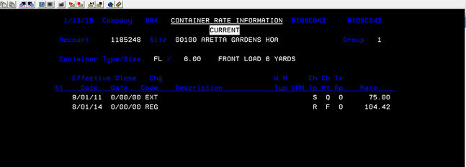

Capture Account_Rate table is correct

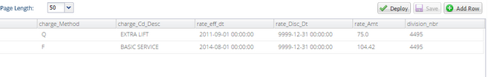

CSA is not correct. Shows $101.70

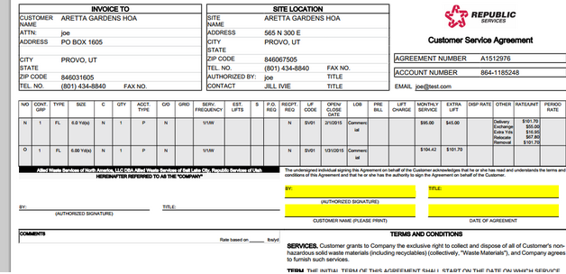

Also, when first entering the SR (Service Revenue) screens the adjustable rate should match the default. Everything seems to match except on EXT (extra lift)

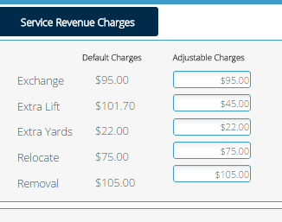

**Design**

Per Brittany. Account Logic should read:

New Account EXT Logic:

1. Look for match in the placemat (NSD table div_ext_serv_price). Match on columns division_nbr, infopro_div_nbr, service_cd, container_cd and container_size.

2. if not found then look for EXT (serviceCode) on InfoProd Division Suggestive Rate Table (div_service_price – InfoPro divisions, serviceCode, containerType)

3. if containerType is not found it step 2 then use the blank container type



4. if InfoPro division is not found then use divison 0

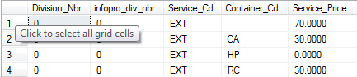

Existing Account EXT Logic:

1. First rate lookup is on the account_rate table. Lookup will be on InfoPro Division, Acct_Nbr, Site_Nbr, Container_Grp_Nbr
2. if not found then use the same exact steps on new account.

**BI or InfoPro**

No Impact

## #265 VCD for removal fee on customer owned container decrease service

**Issue**

Existing customer, customer owned containers, reduce service from 4 to 2. While removal is not charged, the CSA shows a Valued Customer Discount - which is incorrect.

**Design**

Two Options to fix

1. I could remove the line item all together for Existing Customers with Customer owned containers: This wouldn't run the code adding the VCD and we wouldn't be charging them.
2. Or I could keep the line item in place, not list the VCD under comments, and have it zero it out so they aren't being charged.

Please proceed with option 1

**BI or InfoPro**

No Impact

## #233 Approval sent when waiving fees on Existing Cust that have flags already turned off

**Issue**

If you had an Existing account that did not pay fees and you leave the fees off (say during a service change) that this would NOT send an approval trigger. We had one in Gateway today that required approval just due to fees when the fee flags were already turned off.

**Design**

* Look at the prior ERF and FRF values pulled in on the existing account in order to only ask for an approval if the ERF and FRF flags were changed in value from Yes to No (charged to not-charged.)
* Need to modify *postPricingFormulas* to check values *eRFreadOnly_quote* and *fRFreadOnly_quote*when flagging a quote for an approval
* Commerce: *postPricingFormulas* modified to look at both *isFRFwaived_quote* and*fRF_readOnly_quote* AND *isERFwaived_quote* and *eRFreadOnly_quote*for flagging the approval for FRF and ERF respectively.

**BI or InfoPro**

No Impact

## #59 Change of Owner: backdating, start date and bill to information

**Issue**

Ability to back date - change the contract effective date and open/close dates as the last step before they finalizing quote

**Design**

Per Mike Guilleaume - For all activities the eff_date can go back to the first day of the previous month (example: if today is 3/6 they can go back to 2/1)

**BI or InfoPro**

No Impact

# InfoPro Interface

No new variable should be needed and no existing variables should be repurposed for any of the above changes.

# Report Changes

NA

# Appendix